**Singleton pattern**

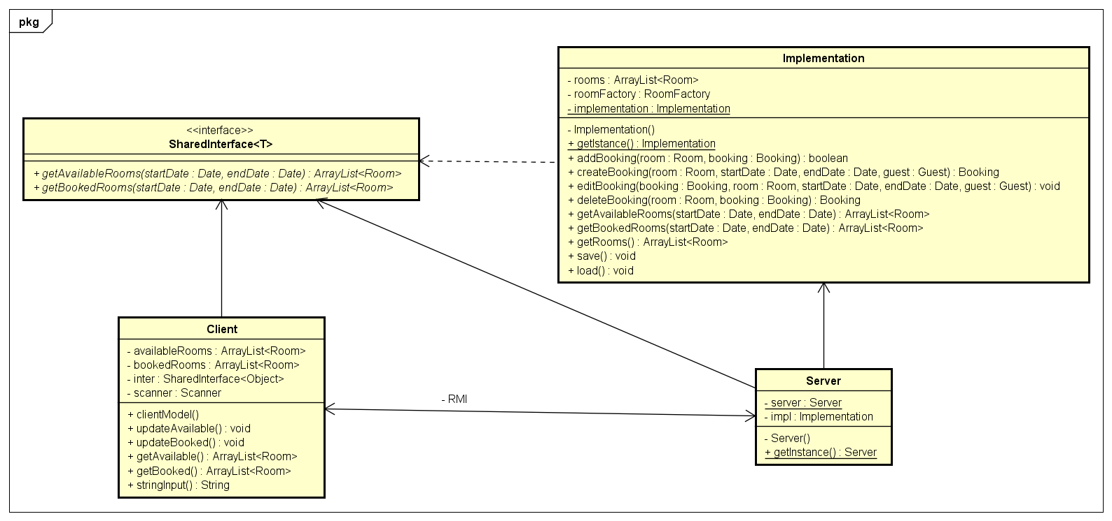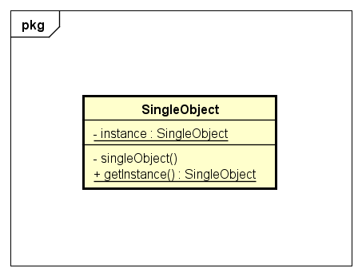

In our project only one instance of Implementation class is needed because it is the core of our program. It operates with unique data which is loaded and saved from an external file. On the other hand, methods from the Implementation class may need to be called from various places in our code. One solution is to pass an Implementation instance around as a parameter to all classes which use its methods. This is possible but inconvenient so in this situation we find the singleton design pattern as very useful. With singleton design pattern there is always exactly one instance of a class allowed. With this approach, we have global visibility to this single instance, via the static getInstance method of the class.